Maintenance of pH meter – HI 2210 with electrode HI 1131 (FEM lab)

**Store electrode in protective cap with a few drop of fresh storage solution**

**Note: NEVER STORE THE ELECTRODE IN DISTILLED WATER.**

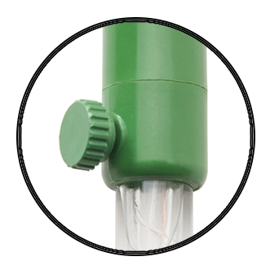

**General Maintenance of electrode**

* Ensure electrolyte solution is within 1.5cm of the top of the electrode.
* If level is low, top up with electrolyte solution (HI7071) by opening the green valve (as shown on right) and gently pipetting in.
* Allow the electrode to stand upright for 1 hour in storage solution
* Recalibrate

**Replacing Electrolyte solution**

* If electrolyte solution is dirty or meter inaccurate, you may need to replace electrolyte solution
* Rinse the electrode with distilled water,
* Open green valve, as for topping up electrolyte and hold electrode at an angle to allow fluid to drip out. Use a pipette to pull fluid out of electrode.
* Refill the reference chamber with fresh electrolyte (ONLY use Hanna solution HI7071)  
  Allow the electrode to stand upright in storage solution for at least 1 hour before taking measurements.

Add date when electrolyte last replaced:

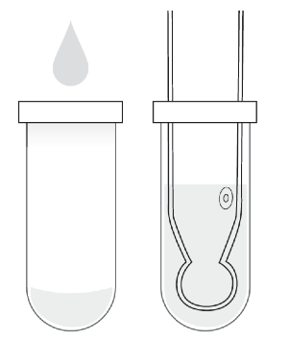**HANNA electrode**

Store electrode with cap on & add a few drops of storage solution provided

**NEVER store in distilled water**

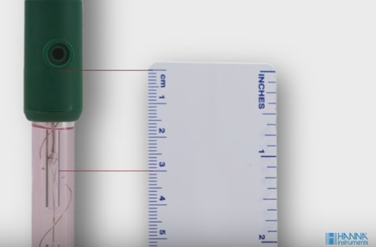

Please keep an eye on level of electrolyte solution – if it drops 3 cm below valve opening it must be topped up with HI7170 solution (see FEM lab protocols)